See live video instructions at ltnled.com
CHASE LIGHTS
Required tools:
- Drill  - Allen keys #3, #4  - 5/32 drill bit  - 4/20mm triangle drill bit  - T 40  - T 25  - T 15  - Alcohol  - Cleaning Cloth  - Zip ties ( 11in, 6in, 4.1in)  - 8mm socket | - Wire cutters  - Wire strippers  - Scissors  - Shrink wrap (size: ⅛, ¾)  - Wire Loom  - Zip tie adhesive tabs  - Heat gun  - Loctite Super glue (or preferable super glue)  - Yellow ring terminal stud  - 8mm Self tapping screw

Front End:

The front end is made up of the Top eyebrow, middle eyebrow, and bottom eyebrow, and the angle located under the middle eyebrow. (2020 model)

The front end is made up of the Top eyebrow, middle eyebrow, 80mm halos, and 100mm halos. (2019 and earlier models)

Steps:
First: Spray your cleaning cloth with alcohol and wipe down the areas you wish to place the light strips. This helps ensure the adhesive of the strip will stick to the surface of the Slingshot. Do not take the tape off the adhesive until you are ready to place the strips. This will help keep dirt off of the light strip glue and make it stick better.

Second: Lay out the light strips to the corresponding sides of the bike. The driver lights are labeled as well as the passenger lights. Each light will have arrows showing the directional flow for the light. The directional flow of the light will need to be the same for each light strip in order for the directional flow of the light to be in sync.

Third: Place your strips in the locations indicated:

DRIVER SIDE:
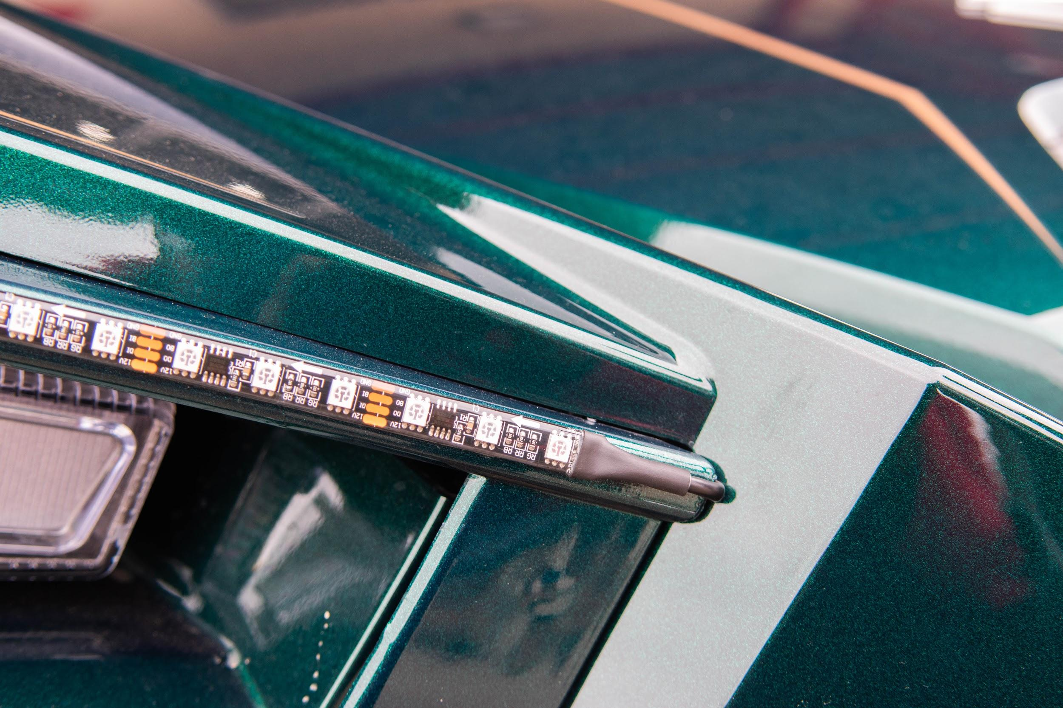
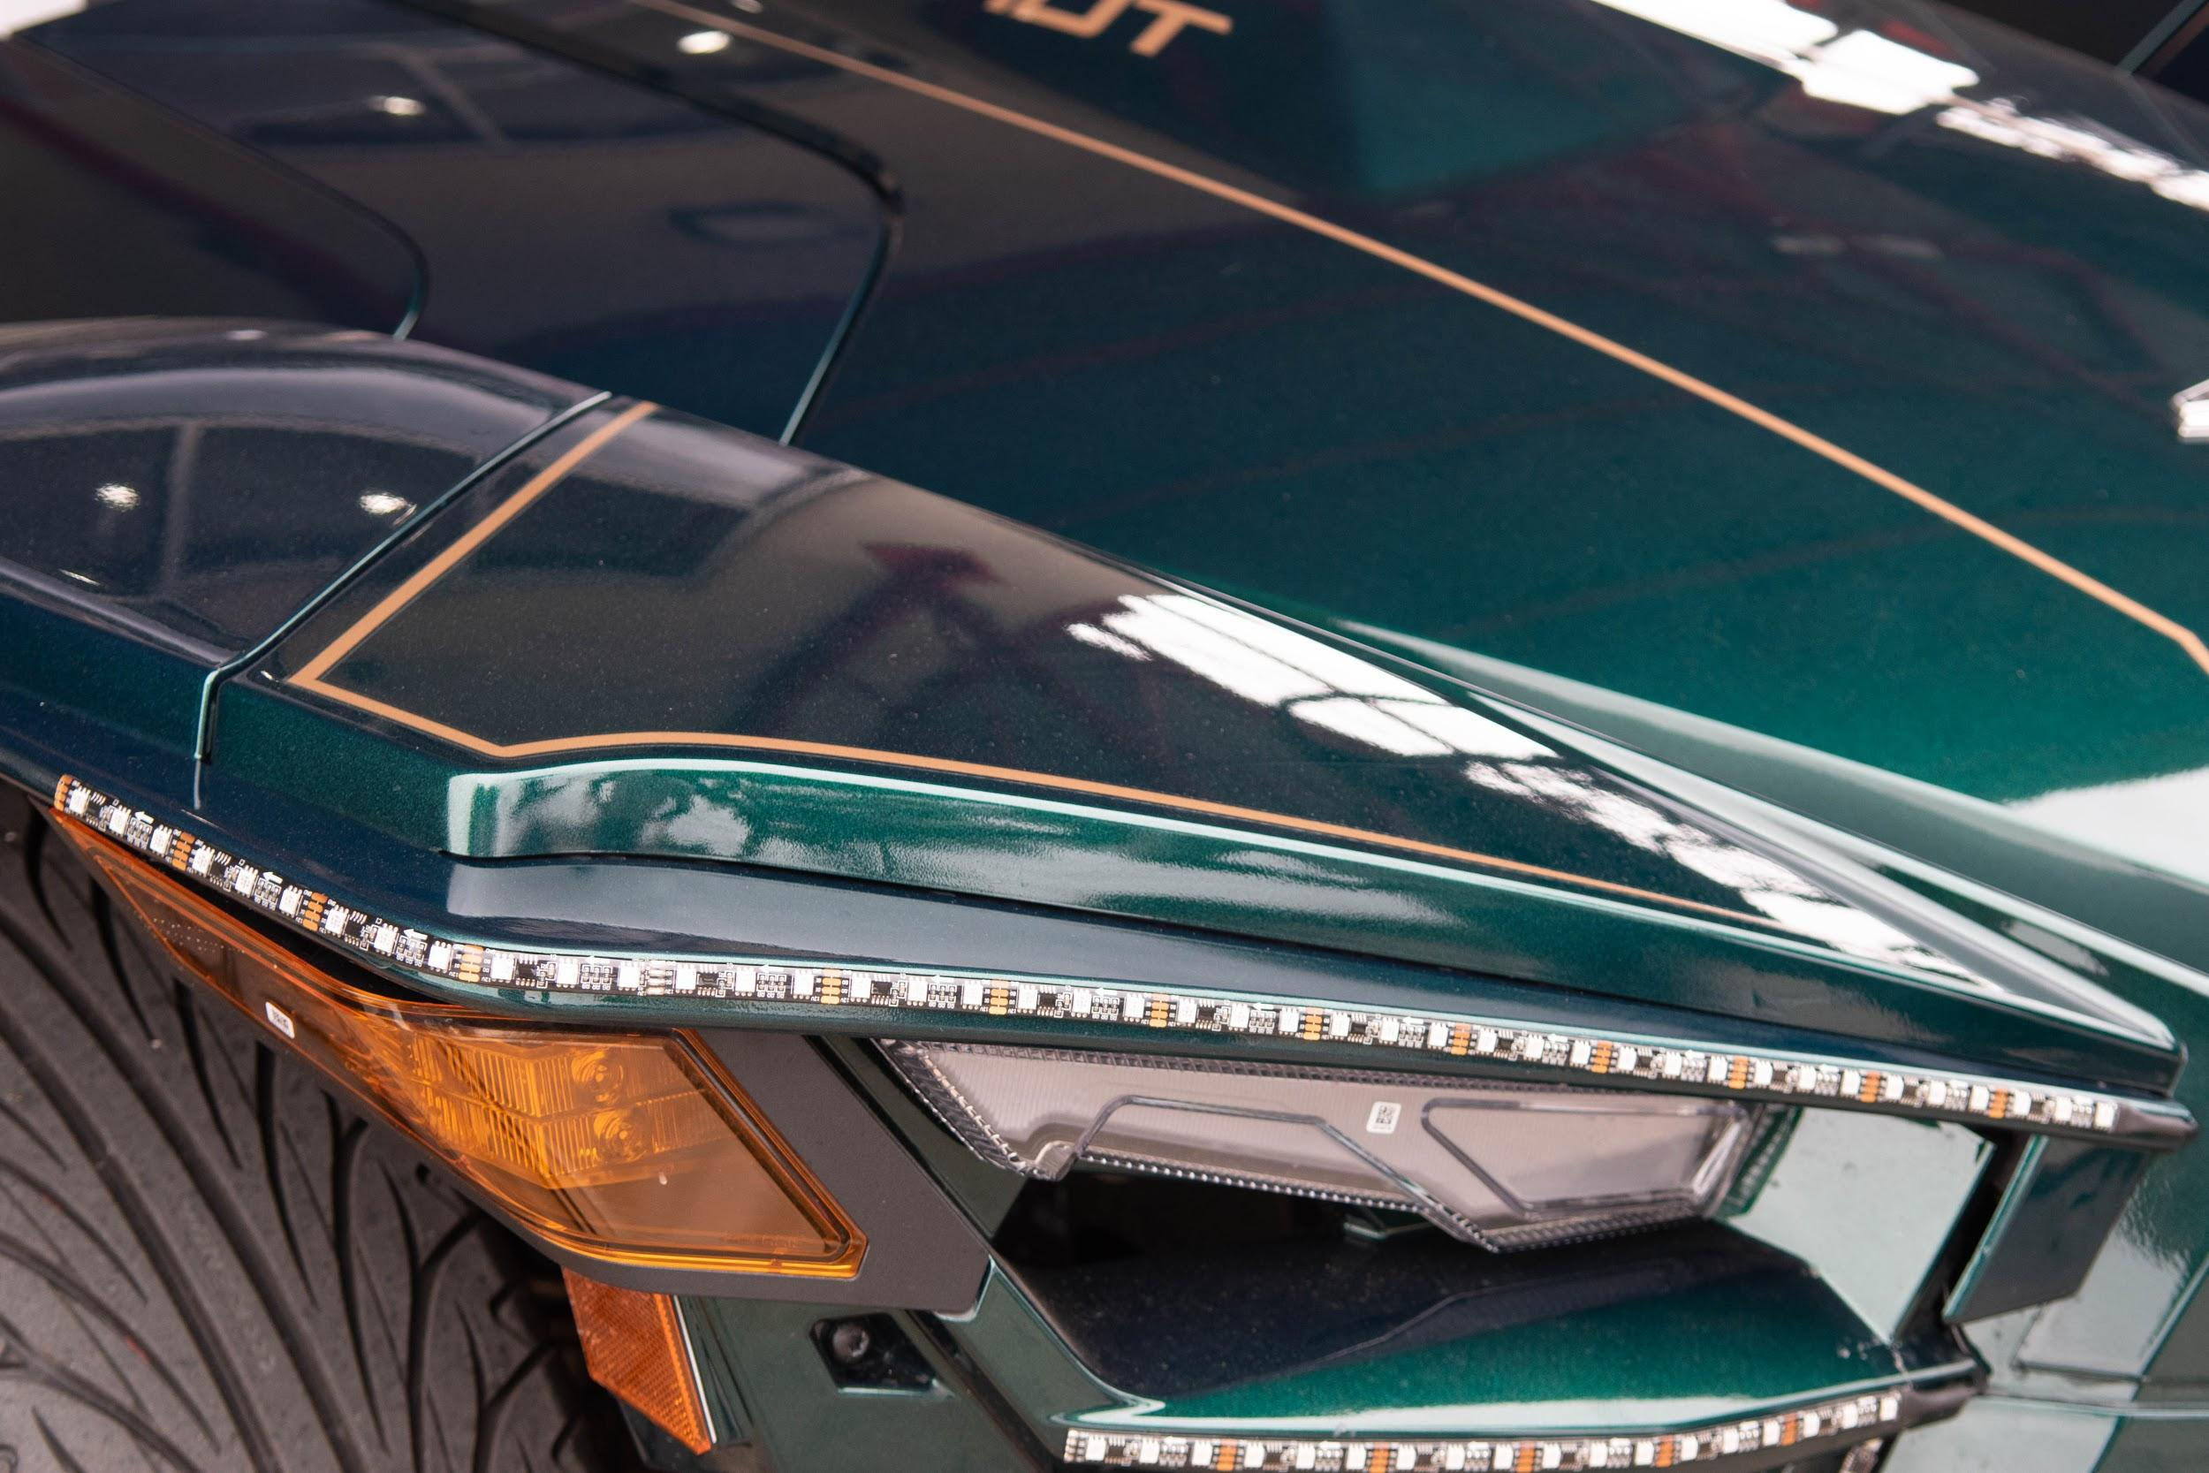
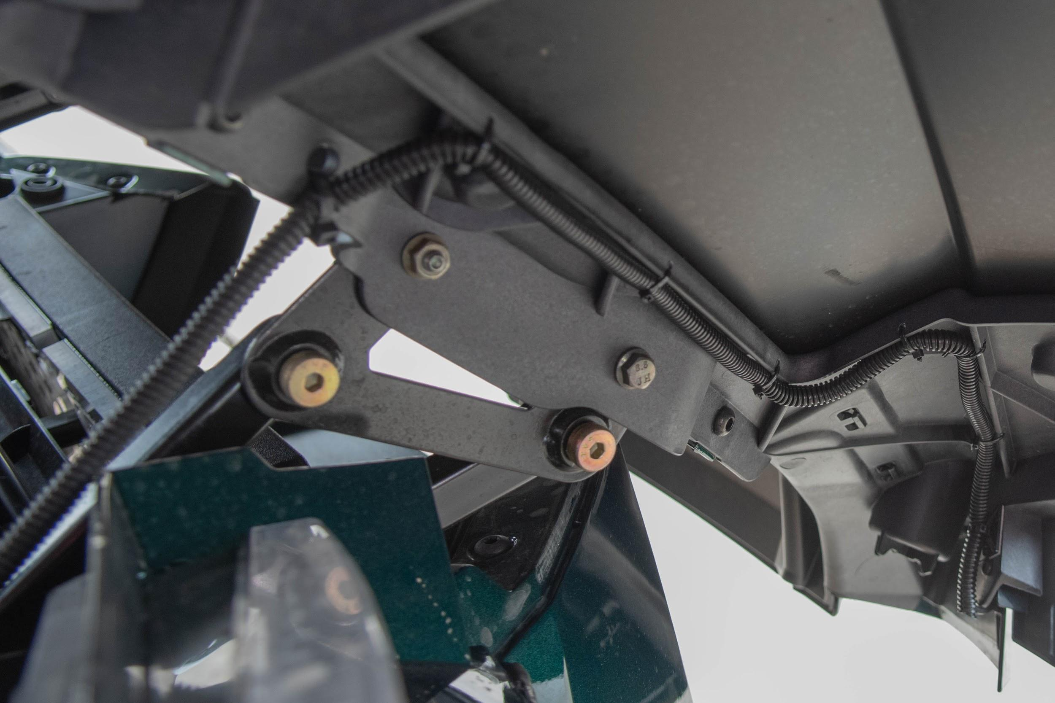
Driver - Top eyebrow [4ft / 7ft] (2020, 2019) - Wipe the area with a cleaning cloth and alcohol. Use caution for the following; you will need to wedge the cable of the light in the corner of the Slingshots eyebrow. The T 25 is able to loosen up the screw behind the eyebrow to allow the cable to better align with the eyebrow. Follow the top trim of the eyebrow and cut on the copper lines to the desired length. (Note: the Light strips can only be cut along the copper lines) Place strips when ready. After placing the light strip, loom the remaining cable. Open the hood and examine the area of the strip. Grab the drill and attach the 5/32 drill bit. Use caution when drilling the holes along the hood. You will need to drill 5 holes going up the hood. Make sure they are evenly spaced to help prevent the cable from getting caught on any obstructions. Once the holes are finished, you will need a zip tie tab to secure the cable at the base. Then, follow the holes and zip tie the cable along the holes until you reach the final one. After that, you will need to grab the remaining cables from the middle eyebrow and the angle to secure it along the side bar of the bike. There will be a wire running from the headlights. Follow the pre-existing cable while tucking the wire under the pre-existing cables. Then run the cable along the middle bar and secure it away from the engine with zip ties. The cable will reach the 8 to 1 splitter box where it will be connected. Take the time to go over and review the cable while cutting off the excess zip ties.

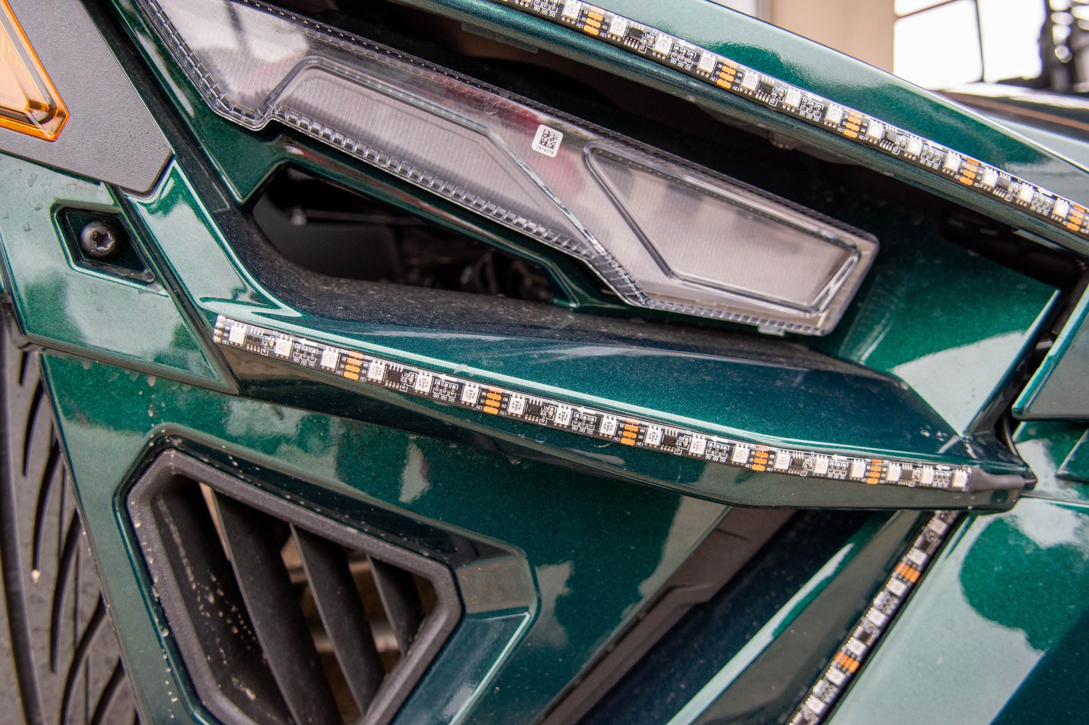
Driver - middle eyebrow [ 2ft / 2ft] (2019/2020 models) - Wipe area with cleaning cloth and alcohol. Feed the cable of the light strip into the corner of the middle eyebrow. Feed the middle eyebrow through the gap of the joint where the hood meets the fender. Follow the top trim of the middle eyebrow and cut on the copper lines to the desired length. Apply the light strip when ready. Loom the remaining cable and secure the base of the cable to the frame of the bike with a zip tie. There will be a bracket on the frame where you can zip tie the cable. After that, group the angle strip and the top eyebrow together and secure it across the frame of the bike. The 8 to 1 splitter box will be on the passenger side of the bike. Run the cable along the sidebar of the frame. There will be a wire running from the headlights. Follow the pre-existing cable while tucking the wire under the pre-existing cables. Secure the cable with zip ties. Go across the middle bar connecting the bike and make sure to keep away from the engine. Review the cable to make sure it sits flat on the bike and cut off any remaining zip ties.

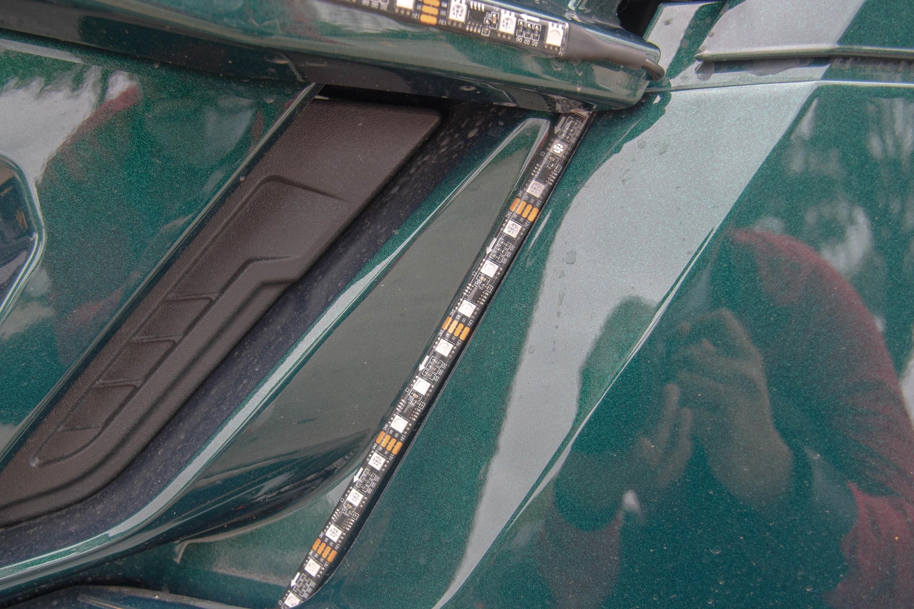
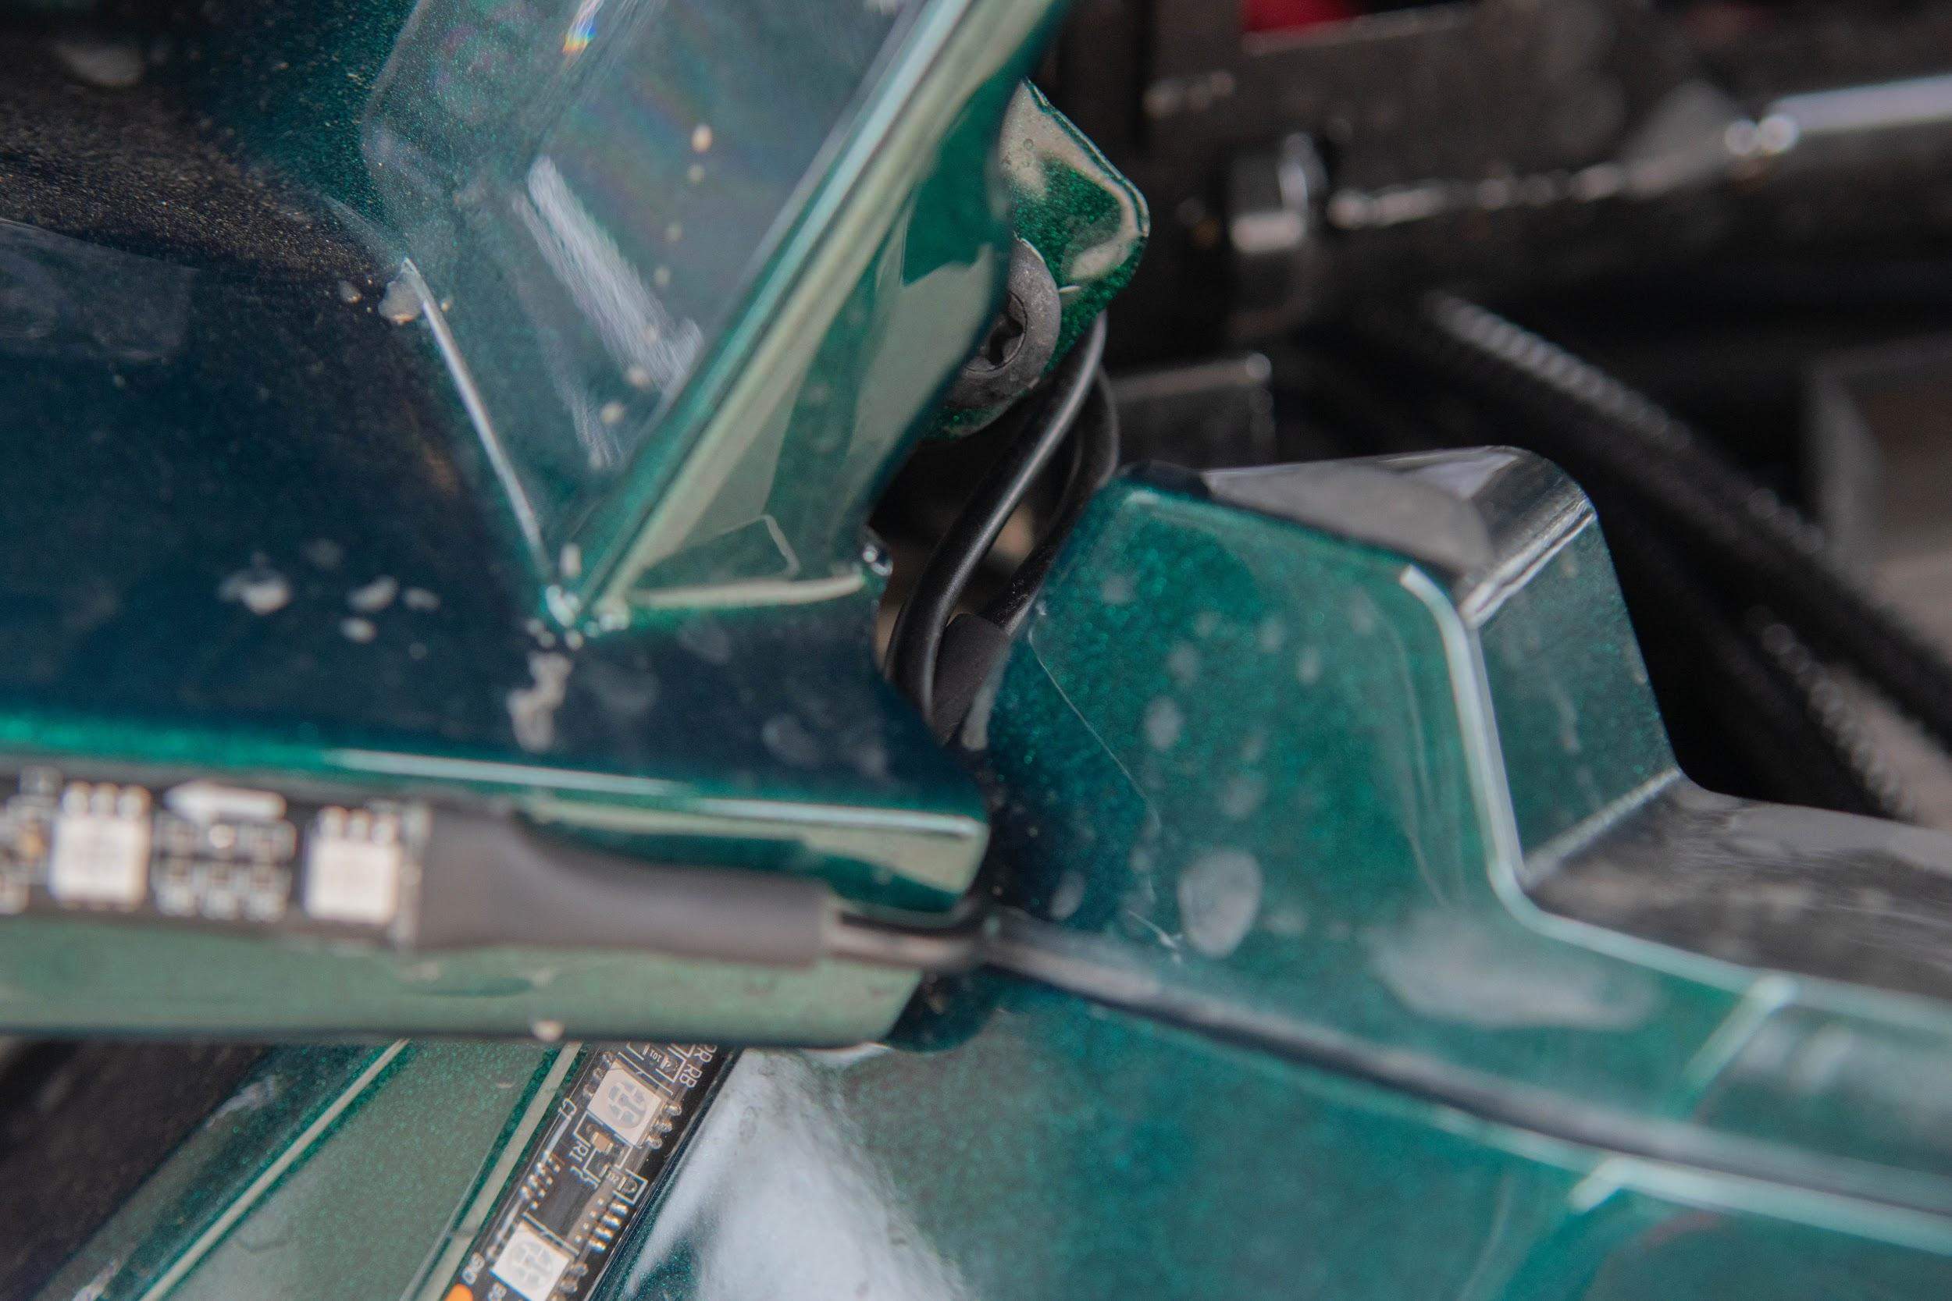
Driver - angle [1ft / 2ft] (2020 model) - Wipe area with cleaning cloth and alcohol. Feed the cable of the light strip under the middle eyebrow. The beginning of the light strip should sit in the top corner and will meet the middle eyebrow. Then, proceed to cut the last three lights off of the cable and measure it to fit. On the very bottom of the light strip, one bulb will be tucked behind the frame of the bike. This is the only way the light strip will sit properly. Follow the grove of the angle and place the strip when ready. Loom the remaining wire and secure the cable on the frame of the bike. The middle eyebrow cable and the angle cable will be secured on the same bracket on the frame of the bike. After that, run the cable along the sidebar of the frame. There will be a wire running from the headlights. Follow the pre-existing cable while tucking the wire under the pre-existing cables. Connect the port and review the cable area while cutting off any excess zip ties.

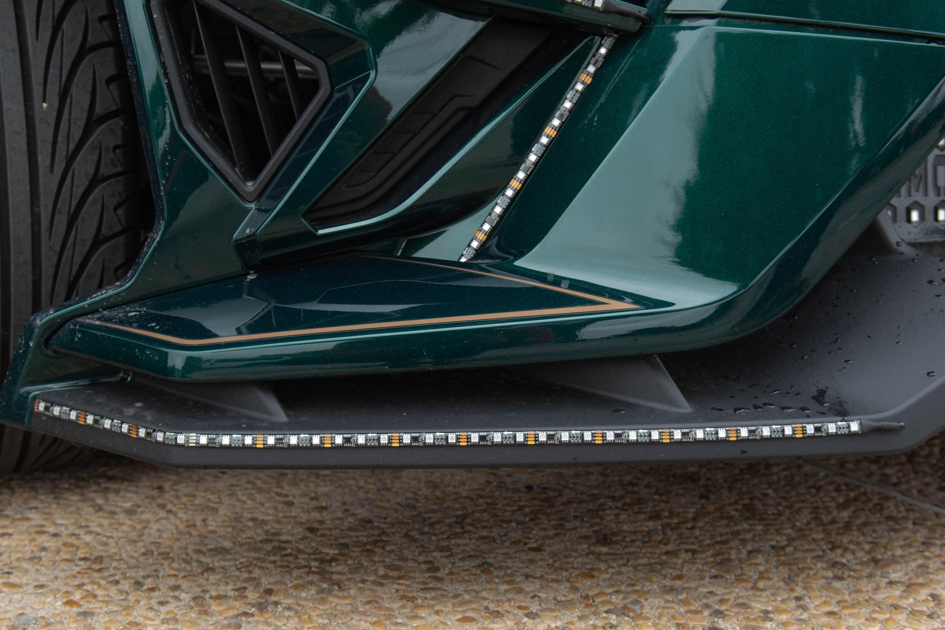
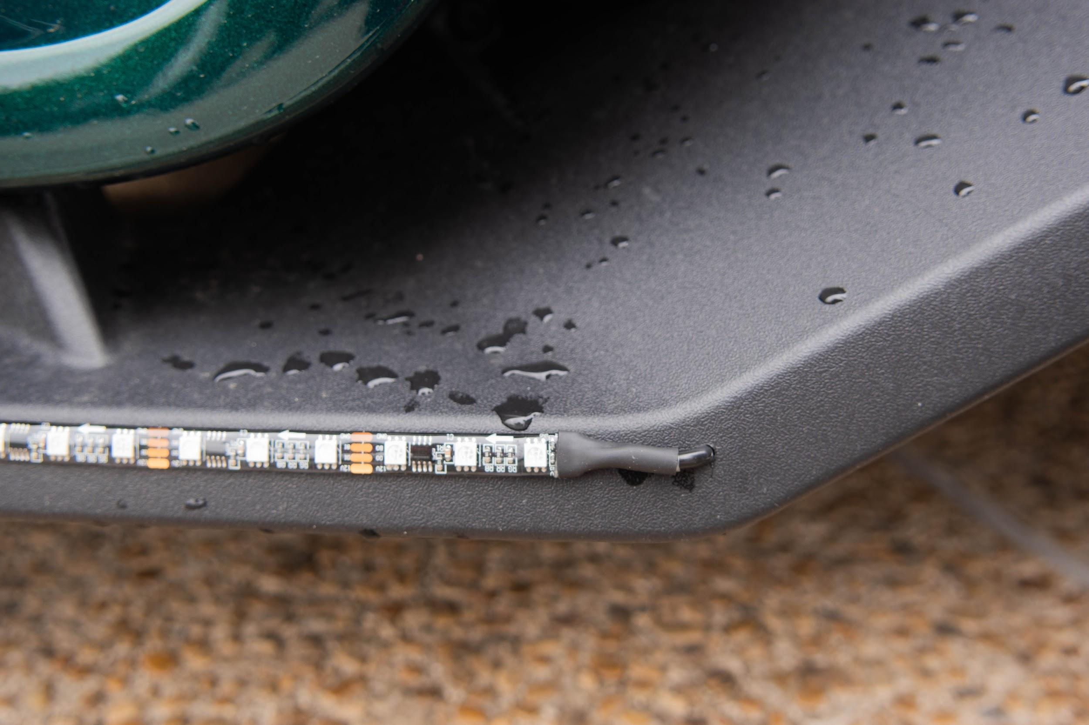
Driver - bottom eyebrow [ 4ft / 7ft] (2020 model) - Wipe the area clean with alcohol and a cleaning cloth. Measure out the light strip to the corner of the bottom eyebrow and cut on the copper line to best fit the corner. The end of the light strip will meet the first curve of the bike and stop just short of it. Follow the top trim of the eyebrow and apply the light strip when ready. Grab the drill and attach the 5/32 drill bit. Make sure to drill along with the light strip so it will sit properly. Once the light strip is placed and the hole has been drilled, proceed to grab the end of the cable with the port. Measure out a foot from the port of the cable and cut the cable. This will allow the cable to go through the hole that was previously drilled. Make sure to hold onto the cut off port; it will need to be reattached. Feed the cable through the hole until the light strip sits flat. Grab the end of the cut off cable and use the wire strippers to expose the wires. Do the same with the cut off port. There will be three wires underneath which are red, black, and yellow. Make sure to strip the wire enough to attach heat shrink wrap to each wire. Attach a size 3 shrink wrap before proceeding on to the main cable. Once enough wire is exposed, match the red wires and tie them into each other and cover with heat shrink wrap. Match the black wires and tie them together then cover with heat shrink wrap. Match the yellow wires and tie them together then cover with heat shrink wrap. Use caution when using the heat gun. Grab the heat gun and proceed to heat up the shrink wrap. Pull the size 3 shrink wrap over the exposed wires and use the heat gun to shrink it. Once all the remaining wire is covered, begin to loom the cable. Run the cable up through the grill and under the roll bar to the 8 to 1 splitter. Use zip tie tabs to help secure the wire on the frame of the bike.
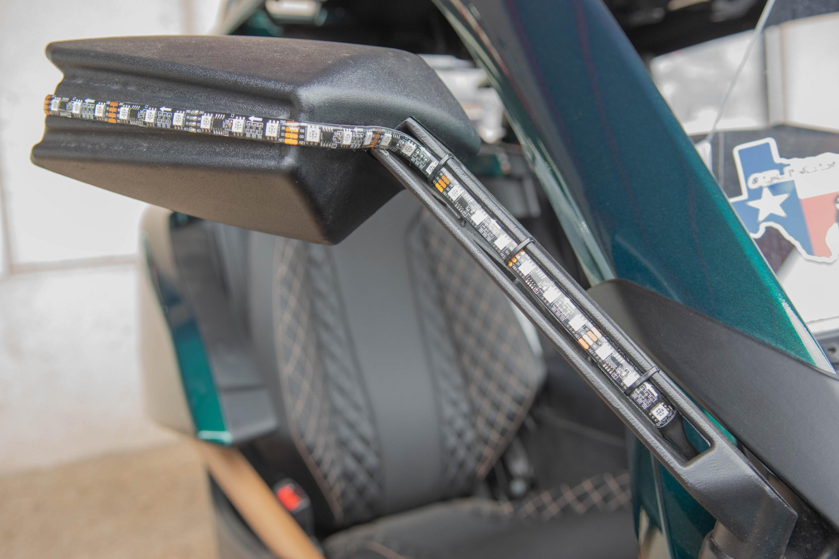
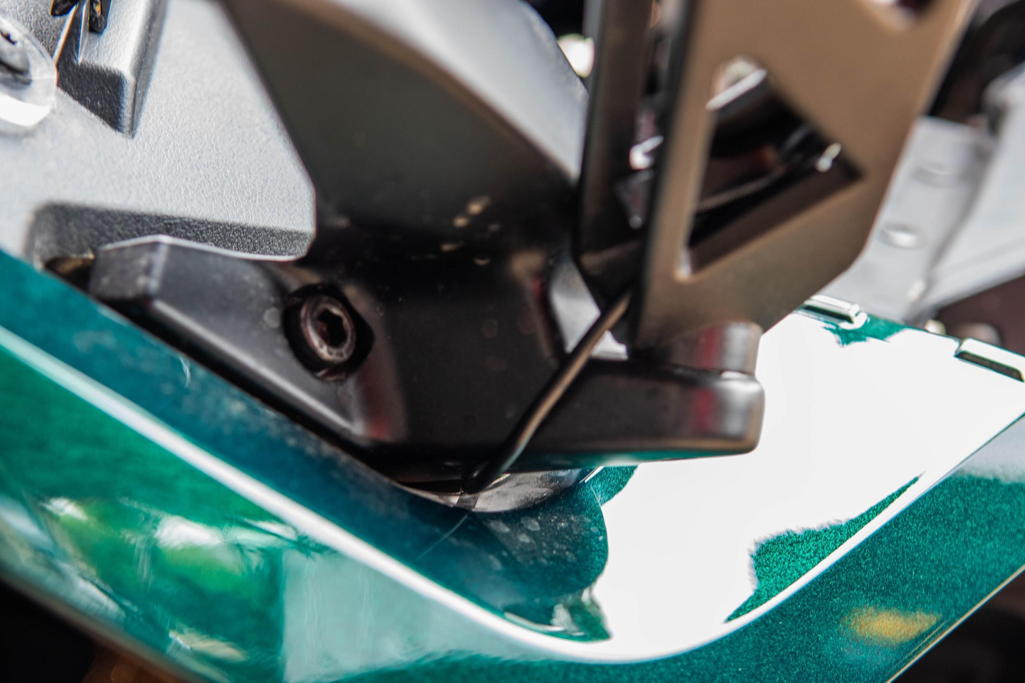
Driver mirror [2ft / 2ft]: Wipe the area clean with alcohol and a cleaning cloth. Please take note, the strip will not sit at the very edge of the mirror, but rather on the first curve of the mirror. Wrap the light strip to the mirror and measure to the copper line. Cut the excess off of the light strip. There are mirror brackets that come with the mirrors to be placed in the open gap of the mirror. Place one piece of double sided 3m tape on the top of the mirror bracket. This will help the bracket sit in the gap when placing the light strip. Before placing the strip, feed the wire cord through the bottom of the mirror and through the frame of the bike. Once the wire is fed through, the wire will drop down to the 8 to 1 splitter in the bucket. Grab hold of the wire and find the other mirror cable and y connect them. After that it will be ready to plug into the 8 to 1 splitter.

100mm & 80mm Halos - Driver and Passenger (2019 model): Locate the smaller ring of each headlight and wipe the area down with alcohol and a cleaning cloth. Grab the drill and attach the 4/20 triangle drill bit and proceed to drill at the bottom of the headlight frame. Once the hole is drilled, feed the cable through the hole and line up the (80mm) halo with the inside of the frame. Place the halo when ready. Feed the cable through the hole. Line up the (100mm) halo on the outside of the frame. Place the halo when ready. Attach Y-connector to each pair of halo’s (100mm and 80mm pair)
100mm & 80mm Halos - Grill (2019 model): Locate the two headlights above the grill and wipe the area with alcohol and a cleaning cloth. Line up the (80mm) halo with the inner frame of the headlight. Place the halo when ready and repeat with the other side. Once the inner halos are placed, fit the (100mm) halos on the outer frame of the headlight. Place the (100mm) halo when ready. Attach Y-connector to each pair of halo’s (100mm and 80mm pair)

PASSENGER SIDE:

Passenger - Top Eyebrow [ 4ft / 5ft] (2019/2020 models) - Wipe the area with a cleaning cloth and alcohol. Use caution for the following: you will need to wedge the cable of the light in the corner of the Slingshots eyebrow if needed. The T15 is able to loosen up the screw to allow the cable to sit more aligned with the eyebrow. Follow the top trim of the eyebrow and cut on the copper lines to the desired length. Place strips when ready. After placing the light strip, loom the remaining cable. Open the hood and examine the area of the strip. Grab the drill and attach the 5/32 drill bit. Use caution when drilling the holes along the hood. You will need to drill 5 holes going up the hood. Make sure they are evenly spaced to help prevent the cable from getting caught on any obstructions. Once the holes are finished, you will need a zip tie tab to secure the cable at the base. Then, follow the holes and zip tie the cable along the holes until you reach the final one. After that you will need to grab the remaining cables from the middle eyebrow and the angle and secure it along the side bar of the bike. There will be a wire running from the headlights. Follow the pre-existing cable while tucking the wire under the pre-existing cables. Run the wire to the beginning of the middle bar where the 8 to 1 splitter is located.

Passenger - Middle Eyebrow [ 2ft / 3ft] (2019/2020 models) - Wipe area with cleaning cloth and alcohol. Feed the cable of the light strip into the corner of the middle eyebrow. Follow the top trim of the middle eyebrow and cut on the copper lines to the desired length. Apply the light strip when ready. Loom the remaining cable and secure the base of the cable to the frame of the bike with a zip tie. There will be a bracket on the frame where you can zip tie the cable. Then, group the angle strip and the Top eyebrow together and secure it across the frame of the bike. Run the cable along the sidebar of the frame along the break line. There will be a wire running from the headlights. Follow the pre-existing cable while tucking the wire under the pre-existing cables. Secure the cable with zip ties. Run the cable to the beginning of the middle bar to the 8 to 1 splitter.

Passenger - angle [ 1ft / 3ft] (2020 model) - Wipe area with cleaning cloth and alcohol. Feed the cable of the light strip under the middle eyebrow. The beginning of the light strip should sit in the top corner and will meet the middle eyebrow. Then proceed to cut the last three lights off of the cable and measure it to fit. On the very bottom of the light strip, one bulb will be tucked behind the frame of the bike. This is the only way the light strip will sit properly. Follow the grove of the angle and place the strip when ready. Loom the remaining wire and secure the cable on the frame of the bike. The middle eyebrow cable and the angle cable will be secured on the same bracket on the frame of the bike. After that, run the cable along the frame of the bike. There will be a wire running from the headlights. Follow the pre-existing cable while tucking the wire under the pre-existing cables. Run the cable to the beginning of the middle bar to the 8 to 1 splitter and connect it.

Passenger - Bottom Eyebrow [ 4ft / 5ft] (2020 model) - Wipe the area clean with alcohol and a cleaning cloth. Measure out the light strip to the corner of the bottom eyebrow and cut on the copper line to best fit the corner. The end of the light strip will meet the first curve of the bike and stop just short of it. Follow the top trim of the eyebrow and apply the light strip when ready. Grab the drill and attach the 5/32 drill bit. Make sure to drill aligned with the light strip for it to sit properly. Once the light strip is placed and the hole has been drilled, proceed to grab the end of the cable with the port. Measure out a foot from the port of the cable and cut the cable. This will allow the cable to go through the hole that was previously drilled. Make sure to hold on to the cut off port; it will need to be reattached. Feed the cable through the hole until the light strip sits flat. Grab the end of the cut off cable and use the wire strippers to expose the wires. Do the same with the cut off port. There will be three wires underneath, which are red, black, and yellow. Make sure to strip the wire enough to attach heat shrink wrap to each wire. Attach a size 3 shrink wrap before proceeding. Once enough wire is exposed, match the red wires and tie them into each other and cover with heat shrink wrap. Match the black wires and tie them together, then cover with heat shrink wrap. Match the yellow wires and tie them together, then cover with heat shrink wrap. Use caution when using the heat gun. Grab the heat gun and proceed to heat up the shrink wrap. Pull the size 3 shrink wrap over the exposed wires and use the heat gun to shrink it. Once all the remaining wire is covered, begin to loom the cable. Run the cable up through the grill and under the roll bar to the 8 to 1 splitter. Use zip tie tabs to help secure the wire on the frame of the bike.

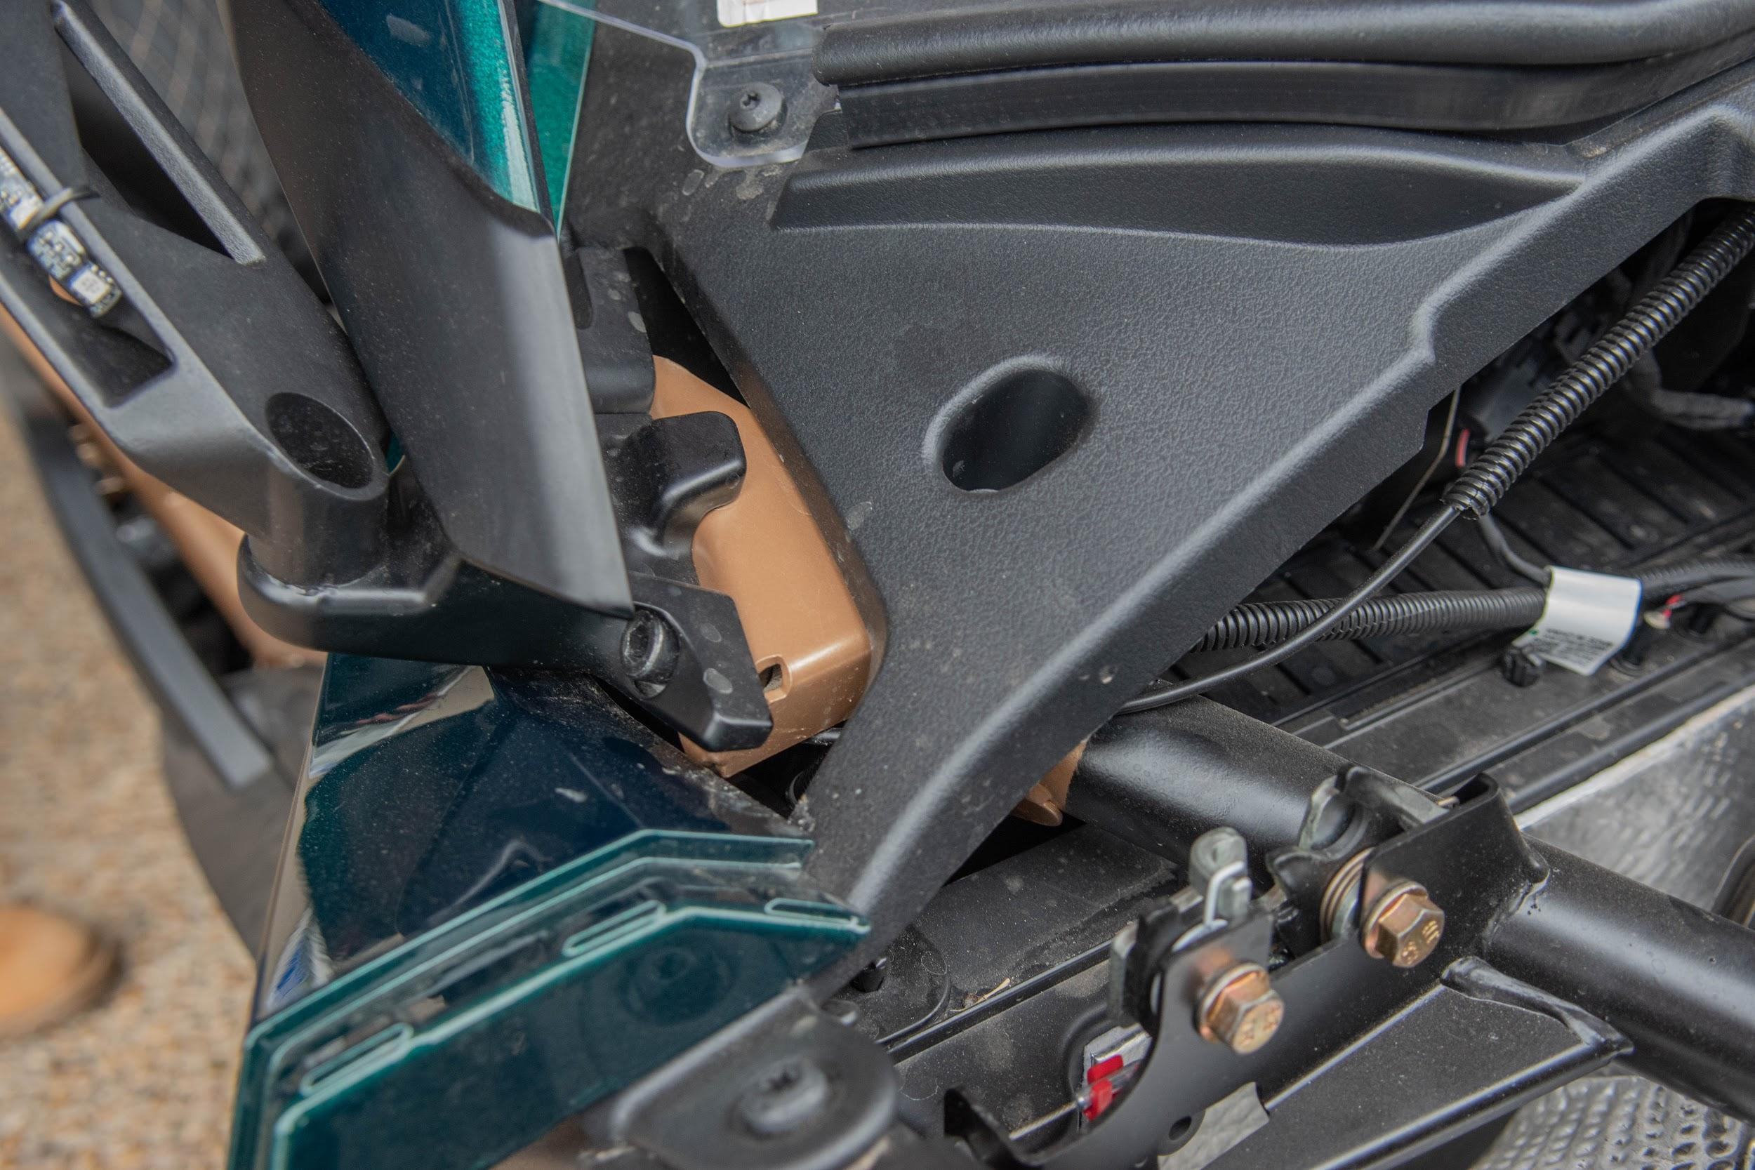
Passenger - mirror [ 2ft 6ft]: Wipe the area clean with alcohol and a cleaning cloth. Please take note, the strip will not sit at the very edge of the mirror, but rather on the first curve of the mirror. Wrap the light strip to the mirror and measure to the copper line. Cut the excess off of the light strip. There are mirror brackets that come with the mirrors to be placed in the open gap of the mirror. Place one piece of double sided 3m tape on the top of the mirror bracket. This will help the bracket sit in the gap when placing the light strip. Before placing the strip, feed the wire cord through the bottom of the mirror and through the frame of the bike. The run of the wire will go across the bike under the hood frame. If tucked correctly, the wire will lead straight to the bucket of the bike and y connect to the other mirror cable.
Back End:

The back end is made up of the center fin, upper roll bar, middle roll bar, and runway (or spring). The directional flow of the light will need to be the same for each light strip in order for the directional flow of the light to be in sync.

Steps:
First: Spray your cleaning cloth with alcohol and wipe down the areas you wish to place the light strips. This helps ensure the adhesive of the strip will stick to the surface of the Slingshot. Do not take the tape off of the adhesive until you are ready to place the strips. This will help keep dirt off of the light strip glue and will make it stick better.

Second: Lay out the light strips to the corresponding sides of the bike. The driver lights are labeled as well as the passenger lights. The directional flow of the light will need to be the same for each light strip in order for the directional flow of the light to be in sync.

Third: Place your strips in the locations indicated:

BEFORE PLACING STRIPS, YOU WILL NEED TO REMOVE THE BACK PANEL AND MIDDLE ROLL BAR.
REMOVE THE BATTERY PANEL FROM THE SLINGSHOT.
THE BATTERY OF THE 2020 SLINGSHOT IS LOCATED AT THE FRONT OF THE BIKE

The tools needed for this are as follows: T 40, T 25, 4/20mm drill bit and a drill. There is a wire connecting the reverse camera that will need to be unplugged in order to take the back panel off. Use caution when disconnecting the wire. There are screws spaced out across the back end of the bike. Take the drill and attach the T40 to the drill. Each screw is a T40 fit and should be individually taken out and placed in a container. Make sure you don’t lose any screws. There will be a screw at the bottom of the back camera, be sure to take this screw out as well. After all of the screws are taken out, go ahead and pop out the back panel carefully.

Center Fin: Wipe the area with a cleaning cloth and alcohol. Measure out and locate the area where the light strip and insulated cable meet. Align the area where the light strip meets the cable with the tail end of the slingshot. Apply the beginning of the light strip to help ensure the light strip fits. Continue to run the rest of the light strip down the inner trim of the slingshot’s center fin. Cut off the last three lights of the light strip to make it fit. (Complete on both sides of the Slingshot center fin). After the placement of the light strip, run the cable down and feed through the end frame of the bike. Both of the cables will go through the frame and be attached with a zip tie. The 8 to 1 splitter box will be located underneath the frame of the bike towards the driver side. Connect the port to the 8 to 1 splitter box and secure with zip ties to the frame of the bike. Review the cable and cut off any excess zip ties.

HEADREST
Before placing strips, remove the plastic shells of the headrest. The top of the headrest will have two T25 screws located at the top and four T40 screws located on the bottom corners of the headrest. Place the screws in a container to avoid losing them. Take the plastic headrest apart and set it to the side.

Driver side Metal Upper Roll Bar: Wipe the area with a cleaning cloth and alcohol. When placing the light strip, line the light strip in the middle of the roll bar. The first copper line of the light strip, starting from the bottom, will line up with the first curve of the upper roll bar. This will help the placement of the light to sit more symmetrical. The directional flow of the light will face left of the bike. The cable of the light strip will feed through the right slit of the frame. Make sure the light strip sticks to the corners of the roll bar to prevent them from falling off in the future. Place strips when ready. From there grab the remaining cable and secure it along the frame of the bike with zip ties. Connect the cable to the 8 to 1 splitter. Review the cable and remove any excess zip ties.

Driver Side Plastic Middle Roll Bar: Wipe the area with a cleaning cloth and alcohol. Grab the back end of the head rest; this is where the light strip will be placed. Line up the first copper line from the end of the light strip. This will act as the starting point for the light strip. Follow the middle of the light strip and make sure to go behind the two groves of the headrest where the screws sit. The directional flow of the light strip will be facing to the right and the cable of the light will lead down. The last three lights of the strip will be cut off so that the light will fit. Grab the drill and the 4/20 triangle drill bit and drill though the headrest at the bottom. Drill a big enough hole for the light strip to fill in the hole and sit flat. The cable of the light will go through the left of the headrest. The cable will be left hanging. Attach the rest of the headset and put the T25 screws back on the headrest. If the headrest does not sit correctly, wiggle the cable behind the headrest until it fits. Once the headrest sits correctly, put the T40 screws back on and check the light strip. Be sure to push down any part that comes up, especially in the corner of the headrest. Grab the remaining cable and secure it along the frame of the bike using zip ties. Review the cable and cut any excess zip ties.

PASSENGER SIDE:

Passenger Side Metal Upper Roll Bar: Wipe the area with a cleaning cloth and alcohol. When placing the light strip, line the light strip in the middle of the roll bar. The first copper line of the light strip starting from the bottom will line up with the first curve of the upper roll bar. This will help the placement of the light to sit more symmetrical. The directional flow of the lights will be facing to the right of the bike and the cable will be going down the left of the bike. Place the light strip when ready. Secure the cable along the frame of the bike towards the 8 to 1 splitter. Review the cable and cut off any excess zip ties.

Passenger Side Plastic Middle Roll Bar: Wipe the area with a cleaning cloth and alcohol. Grab the back end of the head rest; this is where the light strip will be placed. Line up the first copper line from the end of the light strip. This will act as the starting point for the light strip. Follow the middle of the light strip and make sure to go behind the two grooves of the headrest where the screws sit. The directional flow of the light strip will be facing to the left and the cable of the light will lead down. The last three lights of the strip will be cut off so that the light will fit. Grab the drill and the 4/20 triangle drill bit and drill though the headrest at the bottom. Drill a big enough hole for the light strip to fill in the hole and sit flat. The cable of the light will go through the left of the headrest. The cable will be left hanging. Attach the rest of the headset and put the T25 screws back on the headrest. If the headrest does not sit right, wiggle the cable behind the headrest until it fits. Once the headrest sits correctly, put the T40 screws back on and check the light strip. Be sure to push down any part that comes up, especially in the corner of the headrest. Grab the remaining cable and secure it along the frame of the bike using zip ties. Review the cable and cut any excess zip ties.

Runway: Clean the area with a cleaning cloth and alcohol. The directional flow of the lights will be facing downwards. Line up the light strip along the trim of the back panel of the bike. Place the strip when ready. The cable of the light strip will run behind the back panel, over the frame of the bike, and towards the 8 to 1 splitter. Secure the remaining cable with zip ties. Review the cable and cut any excesses zip ties.

OR

Spring: Wipe the area with a cleaning cloth and alcohol. The two strips for the runway will be used on the spring. One strip will be placed on the second to last ring of the spring. The cable will need to be secured using a zip tie tab on the side of the swing arm. The cable of the light will hang and will lead along the break line. The second light strip will start from the top of the spring and meet in the middle of the spring. The cable of the second strip will run directly up the back panel while being secured with a zip tie tab. Secure the light strips of the spring with zip ties. Run the cables up to the frame bar and secure it with zip ties. Connect the two ports to the 8 to 1 splitters and review the cable while cutting the excess zip ties.

Underbody:
The underbody is made up of the driver underbody, passenger underbody, and upper underbody.

Upper underbody: Wipe the area clean with a cleaning cloth and alcohol. The cable of the light strip will lay on the driver side of the underbody. The light strip will be placed on the first curve of the frame of the bike and will go across the whole frame of the bike. The end of the light strip will reach the curve on the other side of the bike. The light strip will be symmetrical thus shining light evenly across. Place the light strip when ready. The cable of the wire needs to be turned towards the body of the bike and will be secured along with the driver side eyebrows. The cable will follow the side frame of the bike up to the open wheel bucket. Loom the remaining cable and secure it to the frame of the bike. This cable will be run to the 8 to 1 splitter in the open wheel bucket.

Driver underbody: Wipe the area with a cleaning cloth and alcohol. The cable of the wire will start at the first frame rail and lead to the open wheel bucket of the bike. The light strip will go along the frame of the bike and reach the last curve of the bike. Place the light strip when ready. The cable will lead directly to the 8 to 1 splitter in the open wheel bucket.

Passenger underbody: Wipe the area clean with a cleaning cloth and alcohol. The cable of the light strip will start just past the frame rail. The cable will need to be tucked behind the heat shield to keep the cable from burning up under the bike. Make sure to put the cable run along the side of the bar in order to keep the cable away from potential damage. The cable of the bike will go across the frame and be secured with zip ties. The cable will lead the to the open wheel bucket and connect to the 8 to 1 splitter.

WHEELS

Driver Side Wheel: Grab an impact drill with a 17mm socket attached to it to take off the lug nuts on the wheel. Put them in a safe location and do not lose them. Carefully take the wheel off and set it to the side. The break will need to be detached from the rotor. There will be two 17mm sized socket bolts at the top and the bottom of the brake. Take the bolts off and set them to the side. Once the brake is off, suspend it with a hook and bungee cord to keep the tension off of the brake line. Pull off the rotor and place it to the side, but make sure not to touch the face or back of the rotor. Grab the wheel ring and carefully pull the brake through the wheel ring. Once the brake is through the wheel ring place to rotor back on the hub and attach the brake to the rotor. The wheel ring will be aligned with the holes for the brake bolts. Put the Blue Lock Tight on both bolts before screwing the bolts in. Once the bolts are in place, use a torque wrench and set it to 65lb/ft and tighten the bolt. Please do not forget this step or the brake caliper could vibrate off. Grab the wheel and attach it back to the hub and secure it. Put the wheel back on the ground before using the torque wrench. Set the torque wrench at 75lb/ft then secure the lug nuts. Do not forget this part because the wheel may come loose.

Once the wheel ring is in place, run the cable to the bucket of the bike. Follow the brake line and secure the cable of the lights with zip ties. Do not over tighten the zip tie or it may cut into the cable and damage the wires. Run the rest of the cable to the bucket and either connect the cables to the 8 to 1 splitter or let it hang until the 8 to 1 splitter is installed.

Passenger Side - Wheel: Grab an impact drill with a 17mm socket to take off the lug nuts on the wheel. Put them in a safe location and do not lose them. Carefully take the wheel off and put it to the side. The brake will need to be detached from the rotor. There will be two 17mm sized socket bolts at the top and the bottom of the brake. Take the bolts off and put them to the side. Once the brake is off, suspend it with a hook and bungee cord to keep the tension off of the brake line. This will ensure unnecessary damage to the brake. Pull off the rotor and place it to the side, do not touch the face or back of the rotor. Grab the wheel ring and carefully pull the brake through the wheel ring. Once the brake is through the wheel ring, place the rotor back on the hub and attach the brake to the rotor. The wheel ring will be aligned with the holes for the brake bolts. Put the Blue Lock Tight on both of the bolts before screwing the bolts in. Once the bolts are in place, use a torque wrench and set it to 65lb/ft and tighten the bolt. Please do not forget this step because the brake caliper could vibrate off. Grab the wheel and attach it back to the hub and secure it. Put the wheel back on the ground before using the torque wrench. Set the torque wrench at 75 lb/ft then secure the lug nuts. Do not forget this part because the wheel may loosen.

The cable of the lights will run across the brake line; secure the brake line with zip ties. Do not tighten the zip ties all of the way, because this will interfere with the brake line. The cable will be fed across the middle bar of the frame. Once the cable reaches the other side of the bike, run it to the bucket of the bike along with the rest of the cables.

Back Side Wheel: Grab an impact drill with a 17mm socket attached to it to take off the lug nuts on the wheel. Put them in a safe location and do not lose them. Carefully take the wheel off and put it to the side. The brake will need to be detached from the rotor. There will be two 17 sized socket bolts at the top and the bottom of the brake. Take the bolts off and place them to the side. Once the brake is off, suspend it with a hook and bungee cord to keep the tension off of the brake line. This will ensure unnecessary damage to the brake. Pull off the rotor and place it to the side, but make sure not to touch the face or back of the rotor. Grab the wheel ring and carefully pull the brake through the wheel ring. Once the brake is through the wheel ring, place the rotor back on the hub and attach the brake to the rotor. The wheel ring will be aligned with the holes for the brake bolts. Put the Blue Lock Tight on both of the bolts before screwing in the bolts. Once the bolts are in place, use a torque wrench and set it to 65lb/ft and tighten the bolt. Please do not forget this step because the brake caliper could vibrate off. Grab the wheel and attach it back to the hub and secure it. Put the wheel back on the ground before using the torque wrench. Set the torque wrench at 75lb/ft then secure the lug nuts. Do not forget this part because the wheel may loosen.

The back wheel is going to run across the brake line; secure the brake line with zip ties. Do not tighten the zip ties all of the way, because this will interfere with the brake line. The cable will run through the middle of the bike but be kept to the side. There will be existing wires that run from the back of the bike that can be followed to the front of the bike. Secure the cable with zip ties along the existing wires of the bike. This will help keep the wires away from the heat of the exhaust and engine. The cable will run to the bucket and come from the bottom of the bucket. Connect the cables to the 8 to 1 splitter box.

POWER
DISTRIBUTION BLOCK PLACEMENT
Place the blocks as shown in the picture for the best outcome
Take the cover off the distribution blocks and add 3m tape to the bottom of both blocks.
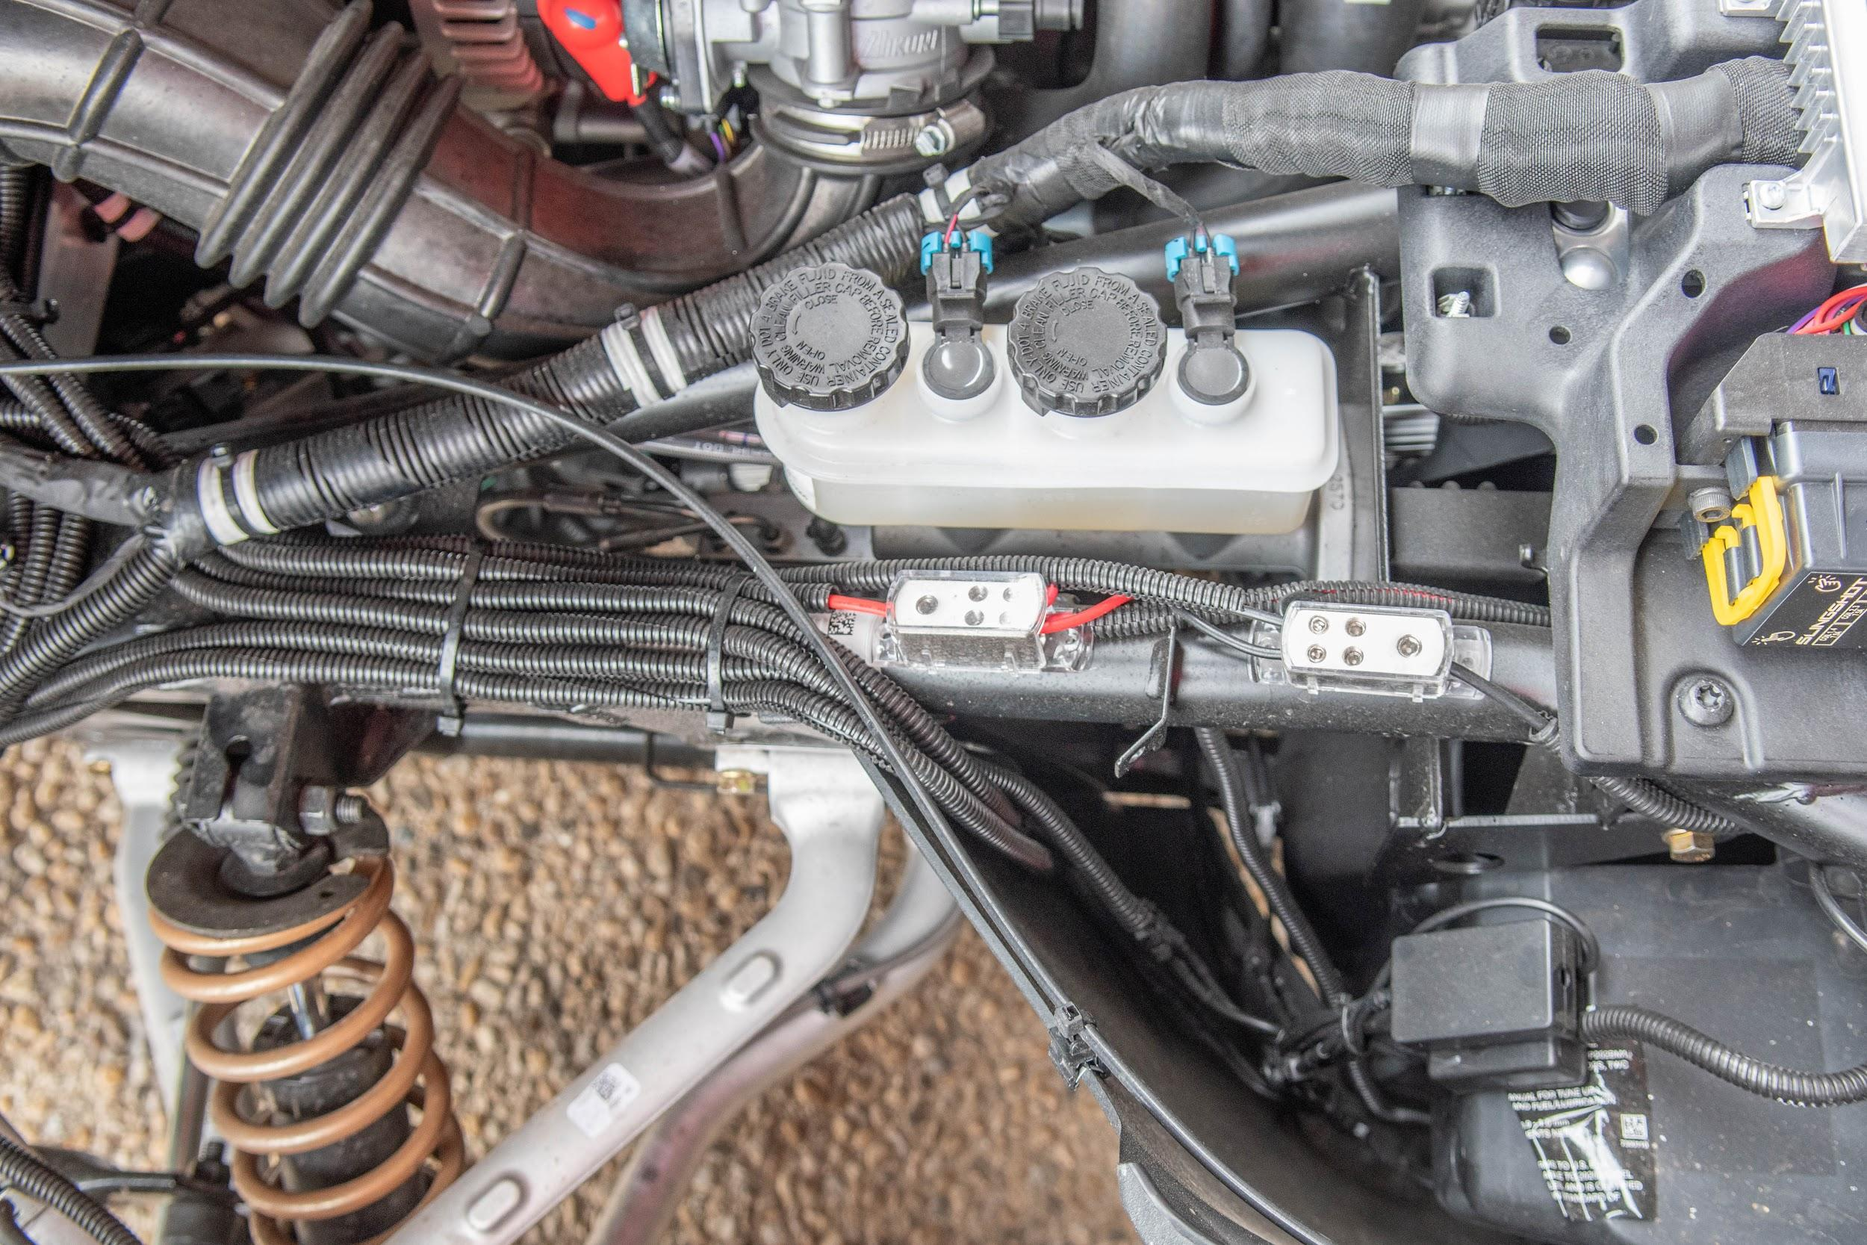
POWR
BLOCK
GROUND
BLOCK

(8 To 1 Splitters): If the run of all the wires are done correctly then the power and ground wire from each 8 to 1 splitter will be in the open wheel bucket. Make sure the cables are not exposed and do not touch any metal. It may short out the system.

Use the #3 Allen key to turn the top right screw of the ground block. Be careful to not loosen the screw all the way or it will fall out. Grab the ground wire for the eyebrow box and strip the wire with wire cutters. Use wire strippers to strip the wire. Twist the end of the ground wire and insert it to the bottom left of the distro block. While the ground wire is inserted tighten the top screw with a #3 Allen key. If done right the wire will be connected to the ground block. Tug the wire to make sure it is secured.
Use the #3 Allen key to turn the top left screw of the power block. Be careful to not loosen the screw all the way or it will fall out. Grab the power wire for the eyebrow box and strip the wire to measure with wire cutters. Use wire strippers to strip the wire. Twist the end of the power wire and insert it to the bottom right of the distro block. While the ground wire is inserted tighten the top screw with a #3 Allen key. If done right the wire will be connected to the power block. Tug the wire to make sure it is secured

Grab the wires for the open wheel bucket box and bring the wires under the frame bar of the bike. Use the #3 Allen key to open the top left of the ground block. Grab the ground wire and measure to strip the wire with wire cutters. Twist the end of the ground wire and insert it to the top left of the distro block. While the ground wire is inserted tighten the top left screw with a #3 Allen key. If done right the wire will be connected to the ground block. Tug the wire to make sure it is secured.
Use the #3 Allen key to turn the top right screw of the power block. Be careful to not loosen the screw all the way or it will fall out. Grab the power wire for the eyebrow box and strip the wire to measure with wire cutters. Use wire strippers to strip the wire. Twist the end of the power wire and insert it to the bottom right of the distro block. While the power wire is inserted tighten the top right screw with a #3 Allen key. If done right the wire will be connected to the power block. Tug the wire to make sure it is secure.

(Ground): The ground wire will come from the toggle switch when it is installed. The wire of the toggle switch will then run to the largest hole of the ground block. Use a #4 Allen key to open the screw in the block. Cut and strip the ground wire to fit the desired hole. It may help to twist the end of the exposed wire to help secure it in the slot. Use the #4 Allen key to secure the ground wire in the block. The wire will then be secured, but make sure by tugging the wire for a double check.
(Power): Use a #4 Allen key to loosen the screw for the biggest slot. Grab the power wire and cut enough off to strip the end and insert it in the biggest slot. It may help to twist the end of the exposed wire to help secure it in the slot. Use the #4 Allen key to secure the screw back in with the power wire. Make sure the cable does not slip out because it can short out the system.

Running the power for 2019 model and earlier: Locate the battery cover at the back of the bike and remove it. You will need a flat sided tool, such as a flat head screwdriver, and pop out the pins holding the cover. There may be T40 screws that will need to be taken out as well. Once the battery is exposed, you will need to grab the 12 gauge power wire and run the wire to the front of the bike. The wire will need to be wedged in the bottom of the bike and the frame of the bike. This will lead to the open bucket area of the bike and straight up to the distribution blocks. The wire should not be exposed or hanging from the bottom of the bike or the wire will be at high risk of damage.

If there is a back end to the bike follow these instructions
DO NOT LET THE POWER WIRE TOUCH METAL OR IT MAY SHORT OUT THE SYSTEM.

Grab the power wire to the 8 to 1 splitter and strip the wire with wire strippers. Use the yellow terminal stud and place it over the exposed wire and use the wire strippers to clasp the yellow ring terminal to the wire. Grab the wires for the backend box and bring the wires under the frame bar of the bike. Use the #3 Allen key to open the bottom left of the ground block. Grab the ground wire and measure to strip the wire with wire cutters. Twist the end of the ground wire and insert it to the bottom left of the distro block. While the ground wire is inserted tighten the bottom left screw with a #3 Allen key. If done right the wire will be connected to the ground block. Tug the wire to make sure it is secured.

Running the power for 2020 models:

Locate the battery of the bike in the front of the bike. Use the 12 gauge power wire and strip the end farthest from the fuse holder. Use a yellow ring terminal stud and clasp it with wire strippers. Use caution when unscrewing the positive screw. Use a flat head screwdriver to loosen the positive screw and put the ring terminal over the screw hole and secure it. The power wire will run along the bottom of the middle frame bar. Secure the wire with zip ties so it does not get close to the engine. Make sure all the power wires are connected and all the wires are in place before inserting the power wire. Use a #4 Allen key to open the biggest screw. Strip the power wire and twist the exposed end to help insert it. While inserted use the #4 Allen key to tighten the screw.

Toggle switch
Go to the steering wheel and detach the bottom casing in order to install the toggle switch. There will be two T25 screws on the bottom of the casing holding it in place. Once those are taken out there carefully pop out the case. Grab a drill and the 4/20 triangle drill bit and drill a hole for the toggle switch in the left side of the case. Grab the toggle switch and screw off the washer and nut. Feed the toggle switch through the hole that was previously drilled and put the washer over the toggle switch with the nut. Secure the toggle switch and flick the switch to make sure it works. Use the two ground wires with the female connecters and attach one to the load and one to the power prongs on the toggle switch. The wires will run to the front of the bike and towards the distribution blocks. Grab the ground wire of the toggle switch and measure the wire to the flat plate at the top of the open wheel bucket and strip the wire to fit. Place the yellow ring terminal over the exposed ground wire and clasp it shut with wire strippers. Grab a 8mm self- tapping screw and put it in the ring terminal. Grab a drill and a 8mm socket to drill the screw in the flat plate of the bike till secure. Do not tighten too much or it will break the screw. Grab the other ground wire from the toggle switch and measure it to fit the largest hole in the ground distribution block. Use the #4 Allen key to unscrew and open the hole at the bottom. Strip the ground wire with wire strippers and twist the exposed end to help secure it in the hole. Use the #4 Allen key to tighten the screw back while the ground wire is in to secure it. Tug the wire to make sure it does not slip out and cause a shortage to the bike. Flip the switch and test out the system. If done correctly the whole system will work, but in the case it does not work check the fuse of the power wire and each box to make sure none of them have popped. If this happens call Lite The Nite LEDs at 1-844-586-5337 for instructions.

